
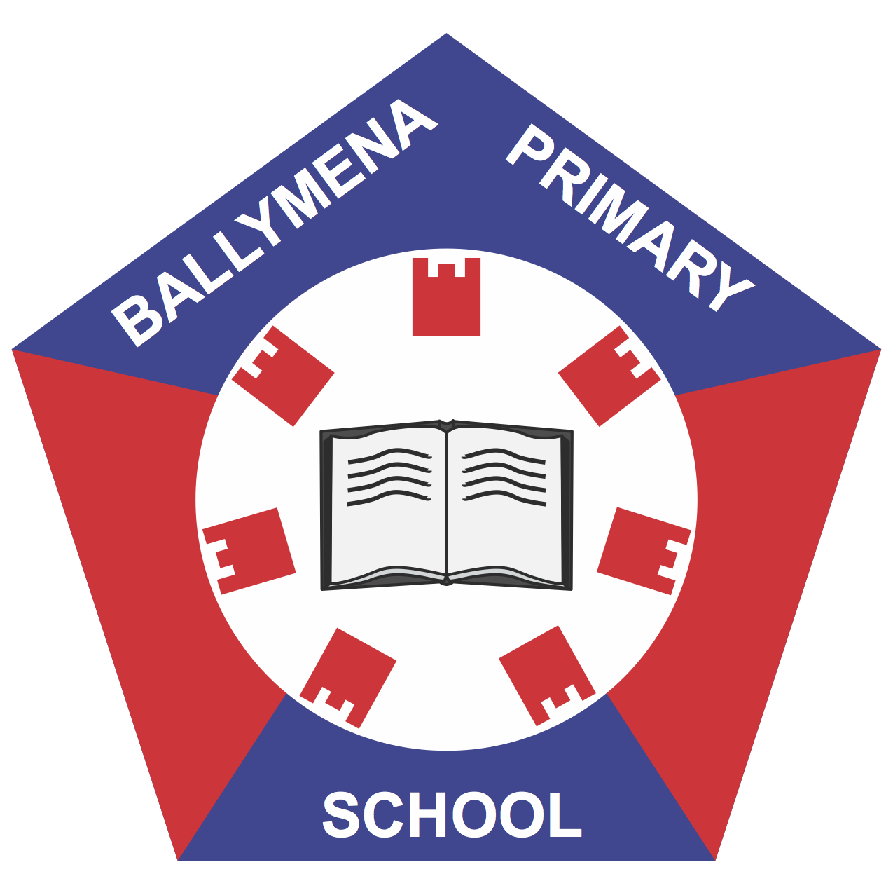

Ballymena Primary School

COMPLAINTS PROCEDURE

May 2023

(To be reviewed,
April/May 2024)

CONTENTS

- Foreword

- Aims of Complaints Procedure

- School Complaints Procedure – at a glance

- Scope of Complaints Procedure

- What to expect under this Procedure

- Making a complaint

- FOREWORD

Here at Ballymena Primary School, we take complaints very seriously. We have the best interests of all our pupils and their families at the centre of all we do. In this regard, we encourage anyone with a concern to speak to us as soon as possible. If concerns are dealt with at an early stage, then they are more likely to be resolved and there is no unnecessary dissatisfaction.
Many issues can be addressed simply by talking to the relevant staff in school who will be happy to help. Open communication and regular engagement between the school staff and the wide range of users is vital to the effective management of the school.
We welcome open communication with our staff; you can speak to staff by:
- Speaking informally with the teacher as the children line up each morning.
- Telephone the school to speak to the relevant member of staff after classes finish at 3 or 4pm.
- Make an appointment at the office to speak with your teacher in person.
- Phone, email or arrange an appointment to speak with the Principal, Mrs E Ritchie to discuss concerns you may have if you continue to be concerned after initial conversations with staff.

If you have any issues please talk to the teacher / head of year as soon as possible. Concerns about matters other than in the classroom should be raised with the Principal. We take all concerns seriously and make every effort to resolve matters as quickly as possible.

- aims
When dealing with complaints the school will;

- encourage resolution of all concerns as quickly as possible
- provide timely responses to concerns and complaints
- keep you informed of progress
- ensure a full and fair investigation of your complaint where appropriate
- have due regard for the rights and responsibilities of all parties involved
- respect confidentiality
- fully address complaints and provide an effective response
- take appropriate action to rectify the issue and prevent it happening again where appropriate
- be responsive to learning from outcomes which will inform and improve practice within the school.

A copy of this Procedure is available on the school’s website or is available from the school on request.

- COMPLAINTS PROCEDURE –AT A GLANCE

Stage Two

Write to the Chairperson of Board of Governors

Stage One

Write to the Principal

Time Limit
Please contact the school as soon as possible, unless there are exceptional circumstances, complaints will normally only be considered within 6 months of origin of the complaint to the school.

Stage One
When making a complaint, contact the school Principal who will arrange for the complaint to be investigated. If the complaint is about the Principal, proceed to Stage Two. The school requires complaints to be made in writing, where this may present difficulties, please contact the school which will make reasonable arrangements to support you with this process. (see guidance notes for further information)

Please provide as much information as possible including;
- name and contact details
- what the complaint is about
- what has already been done to try to resolve it and
- what you would like the school to do to resolve the complaint.

The complaint will normally be acknowledged within 5 school working days and a response normally made within 20 school working days of receipt of the complaint. This response will be issued in writing by the Principal and will indicate with reasons whether the complaint has been upheld, partially upheld or not upheld.

Please note: These timeframes may need to be reviewed if complaints are ongoing during school holiday periods.

If you remain unhappy with the outcome at Stage 1, the complaint may be progressed to Stage 2 which is overseen by the Board of Governors.

Stage Two
If the complaint is unresolved after Stage One, write to the Chairperson of the Board of Governors (care of the school and marked ‘private and confidential’). Where this may present difficulties, please contact the school which will make reasonable arrangements to support the complainant with this process. The Chairperson will convene a committee to review the complaint. Please provide as much detail as possible as indicated above.

The complaint will normally be acknowledged within 5 school working days and a final response normally made within 20 school working days from date of receipt of the complaint. The response will be issued in writing by the Chairperson of the committee.

Please note: These timeframes may need to be reviewed if complaints are ongoing during school holiday periods.

Northern Ireland Public Services Ombudsman (NIPSO)

If following Stage Two you remain dissatisfied with the outcome of your complaint, you can refer the matter to the Office of the Northern Ireland Public Services Ombudsman (NIPSO).

The Ombudsman provides a free, independent and impartial service for handling complaints about schools in Northern Ireland. You have the right to complain to the Ombudsman if you feel that you have been treated unfairly or have received a poor service from a school and your complaint has not been resolved to your satisfaction.

A complaint should normally be referred to NIPSO within six months of the final response from the School. The school must advise in its concluding letter that the complaint may be referred to the NIPSO if you remain dissatisfied.

Contact details for NIPSO are:

Northern Ireland Public Services Ombudsman
Office of the Northern Ireland Public Services Ombudsman
Progressive House
33 Wellington Place
Belfast
BT1 6HN

Freepost: FREEPOST NIPSO

Telephone: 02890 233821
Freephone: 0800 34 34 24

Email: nipso@nipso.org.uk
Web: www.nipso.org.uk

- Scope of complaints procedure

4.1 The Complaints Procedure sets out how any expression of dissatisfaction relating to the school will be managed. By taking concerns raised seriously at the earliest possible stage, it is hoped that issues can be resolved quickly and effectively.
Some examples of complaints dealt with;
- not following school policy
- communication delays / lack of communication
- difficulties in staff / pupil relationships.

4.2 Complaints with separate established procedures

Some examples of statutory procedures and appeal mechanisms are listed below. The list is not exhaustive. The Principal/ Chair of Governors will advise on the appropriate procedure to use when the complaint is raised.

Matters may still be referred to NIPSO, if it is felt that maladministration has occurred.

Exceptions | Contact
- Admissions / Expulsions / Exclusion of children from school  - Statutory assessments of Special Educational Needs (SEN)  - School Development Proposals  - Child Protection / Safeguarding | Contact www.eani.org.uk Director of Operations and Estates  Sara Long  Contact www.eani.org.uk Director of Children and Young People’s Services Dr Clare Mangan  Contact www.eani.org.uk Director of Education  John Collings  Contact www.eani.org.uk Director of Children and Young People’s Services  Dr Clare Mangan

  - The school will not normally investigate anonymous complaints, unless deemed by the Chairperson of the Board of Governors to be of a serious nature. The decision of whether to deal with such complaints will be at the discretion of the Board of Governors. (see guidance notes for further information)

- What to expect under this procedure

5.1 Your rights as a person making a complaint

In dealing with complaint we will ensure;

- fair treatment
- courtesy
- a timely response
- accurate advice
- respect for privacy – complaints will be treated as confidentially as possible allowing for the possibility of consultation with other appropriate parties about the complaint and
- clear reasons for decisions.

5.2 Your responsibilities as a person making a complaint

In making a complaint it is important to;
- raise issues in a timely manner
- treat our staff with respect and courtesy
- provide accurate and concise information in relation to the issues raised
- use these procedures fully and engage with them at the appropriate levels.

5.3 Rights of parties involved during the investigation

Where a meeting is arranged the complainant may be accompanied but not represented by another person.

This Procedure does not take away from the statutory rights of any of the participants.

5.4 Timeframes

Where concerns are raised with the relevant Teacher or Principal, a response will normally be provided during the meeting or within an agreed timeframe.

Stage 1 – Normally acknowledge within 5 school working days, response normally within 20 school working days

Stage 2 – Normally acknowledge within 5 school working days, response normally within 20 school working days

If, for any reason, the review of a complaint takes longer to complete, you will be informed of revised time limits and kept updated on progress.

Please note: These timeframes may need to be reviewed if complaints are ongoing during school holiday periods.

- MAKING A COMPLAINT

6.1 Equality

The school requires complaints to be made in writing. Where this may present difficulties, please contact the school which will make reasonable arrangements to support the complainant with this process.

6.2 unreasonable Complaints
The school is committed to dealing with all complaints fairly and impartially, and to providing a high quality service to those who complain.
There will be occasions when, despite all stages of the complaints procedure having been completed and the complaint having been reviewed by the Ombudsman, the complainant remains dissatisfied. If they try to re-open the same issue, the Chair of Governors will inform them that the procedure has been completed and that the matter is now closed.

If the complainant repeatedly continues to contact the school with the same issue it may choose not to respond.

